Zachary Satchell

London W8

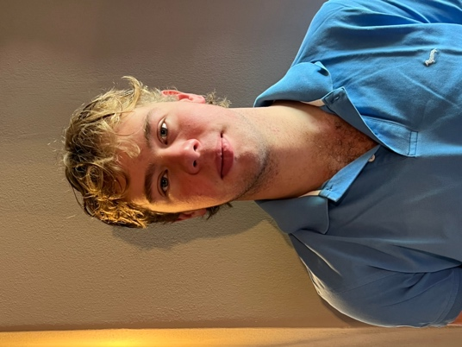

My name is Zac, I am Miss Satchell’s youngest brother and I have just finished my A Levels and I am currently on my Gap Year earning money to travel before going to University next year. I am free after 6.30pm in the evenings to babysit, happy to dog or house sit at weekends. I am available from the 23rd of September until the end of March 2025. I have experience babysitting children as I have multiple cousins under the age of 10. I love animals and I have two dogs and 1 cat at home. Please do not hesitate to contact me.

07796580592
zacsatchell@gmail.com

DOB: 28th August 2005 National Insurance number: PK812408A
Nationality: British

Education:

Marlborough College (2019 – 2024)

A Levels (2022 – 2024)
GCSEs (2022)
Business A* Double Award Science 9/8
Psychology A History 8
Sports Science B Sports Science 8
English Literature 8
EPQ A* Religious Studies 8
Commentating on Formula 1 French 7
Maths 6
English Language 6
Geography 6

Work Experience:

Silverstone Circuits Limited 2024 summer
Retail Sales Assistant for the British Grand Prix and the Classic Festival, selling official radios and brochures for customers across the event. Working in a creative manner to achieve the highest amount of sales possible for the company while providing excellent customer service.

Be Upstanding Marquees 2022-2024 (Ongoing)
Erecting Marquees for events over the summers. Working within a team, communicating and demonstrating a good work ethic over long hours.

Sheelagh Chetwode Catering 2022 – 2024 (Ongoing)
Food preparation and waitering, this includes plating up for formal dinners and hosting skills.

My work experience so far has been diverse and informative. The main aspect learnt from each experience has been the importance of teamwork.

  - Personal Qualities:
  - My teachers, fellow students and friends describe me as: ambitious, thoughtful, responsible, approachable, passionate and engaging.

References:

Tamar Walker
Silverstone Circuits Limited
Tamar.walker@silverstone.co.uk
07966278463

Mr G McSkimming
Housemaster
Barton Hill, Marlborough College
gjm@marlboroughcollege.org
07980702906

Mark Leefe
Be Upstanding Marquees
mark@beupstanding.co.uk
01295768073

Sheelagh Chetwode
Sheelagh Chetwode Catering
Sheelagh.chetwode@btinternet.com
07595548652

