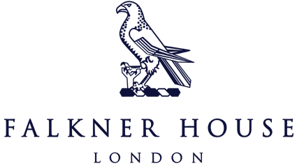

Match report Y3 vs Garden House

11th November 2024

**Albion**

Y3 Albion faced a challenging Garden House team, ending in a 4-2 loss. Unfortunately, we had a very slow start, allowing Garden House to capitalize and score early goals. However, as the game progressed, the boys showed resilience and began to find their rhythm.

There were some great moments of play, and it was encouraging to see positive communication emerging on the field in the second half after a wobbly first half. Despite the final score, the team displayed effort and growth.

**City, Rovers, United**

Falkner House City, Rovers and United took on Garden House in a fantastic series of games, delivering some positive results across the board. Each team played with energy, skill, and a great attitude, showing how much they’ve been developing their football this term.

The boys worked well together, passing smoothly, communicating effectively and supporting each other on and off the field. It was clear how much they enjoyed the experience, with plenty of smiles and high fives shared throughout. Their positivity and sportsmanship made for a great day and we’re proud of how well they represented Falkner House.