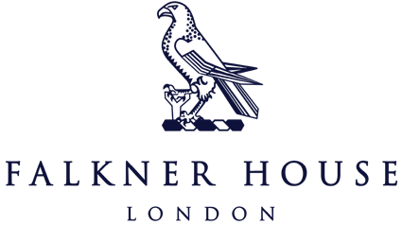

Match report Y3 vs Eaton House

18th November 2024

**Albion**

Falkner House Albion put on a sensational display to secure a 5-1 victory over Eaton House in a thrilling football match. The boys played with incredible energy, showcasing a perfect blend of skill, teamwork and determination throughout the game.

From the opening whistle Albion looked sharp, moving the ball with confidence. The goals came from a mix of crisp finishing and clever passing combinations, with each strike met by cheers from the sidelines.

What stood out most was the camaraderie and enjoyment among the boys. Each player contributed to the team’s success, celebrating every goal and working hard for one another. It was a true testament to their sportsmanship and love for the game.

Well done to Albion for an outstanding performance! They should be proud of the way they represented themselves and Falkner House. Keep up the fantastic work boys.

**City**

City had a very dominant 1st half display and saw them earn a 6-4 win against Eaton House. The boys were out of the blocks from the first whistle, pressuring the Eaton House defense, winning the ball back and creating a lot of chances. They were also very clinical in their finishing, scoring 5 goals very quickly. Eaton House however, did settle into the game after and manage to score 2 goals before halftime.

The 2nd half was a much more even contest, with both teams attacking, creating lots of chances. It felt like at times that it was a basketball game, very end to end. City did score first in the 2nd half. But Eaton House managed to score 2 more goals and tried to create more opportunities to score, but City held on for the win.

Great performance from the boys. Well done!