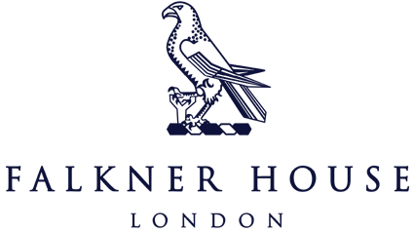

Y4 Match reports v Garden House

8th October 2024

Albion

The Albion boys put on a fantastic display at Holland Park, winning against Garden House 5-0. The team’s chemistry was evident as they moved the ball forward quickly and accurately, demonstrating excellent teamwork and communication throughout the match.

The boys thoroughly enjoyed themselves, celebrating each goal with excitement and camaraderie. They played with skill and determination, but equally showed great respect for their opponents, maintaining sportsmanship throughout the game. This victory not only highlights their talent but also their commitment to playing the game in the right spirit. We look forward to the Cothill House football festival this Friday!

City

In a brilliant display of teamwork and skill, Falkner House City secured a tremendous 3-0 victory against Garden House. From the outset, City showcased brilliant passing, moving the ball fluidly across the pitch and creating numerous chances. Their midfielders linked up beautifully, allowing for quick transitions. Defensively, City were equally impressive. The backline remained resolute, thwarting Garden House’s attempts to penetrate their defenses.

Overall, it was a fantastic performance from the boys, highlighting their growth in both attacking and defensive play.