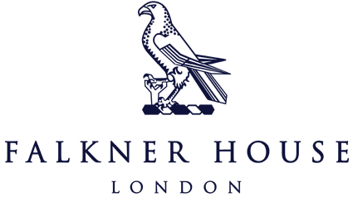

Cothill House Tournament

11th October 2024

Y3

The Falkner House boys showcased outstanding teamwork and skill at the Cothill House Football Tournament, competing in five matches. With a remarkable record of three wins against Cothill House, Eaton House (The Manor), and Knightsbridge B and two draws against Broomwood and Knightsbridge A. They demonstrated not only their talent but also their commitment to sportsmanship, cheering for one another and respecting their opponents throughout the day.

Each game was filled with excitement and fun, and the players’ enthusiasm was evident. The camaraderie among the team made the experience even more enjoyable, culminating in a well-deserved lunch of fish and chips that everyone relished. Overall, it was a fantastic day of football, teamwork, and memorable moments for all.

Results:

FHB 4-0 Knightsbridge B

FHB 1-1 Knightsbridge A

FHB 3-0 Cothill House

FHB 7-0 Eaton House

FHB 2-2 Broomwood

Y4

The Year 4 team were very excited for the tournament. The results were mixed with one win, one draw and two losses. The results didn’t reflect on their performance or competitiveness in every game.

The boys started with a win against Cothill House. The game against MCS was a loss, but their performance deserved more. The 3rd game was a very even game against Broomwood and it ended in a draw. The last game saw the boys play Eaton House. They had played to a high tempo in the previous games, so they were quite tired and Eaton House took advantage of it.

Overall, the boys really enjoyed themselves. They showed good sportsmanship on and off the pitch. They supported each other attacking and defending.

Results:

FHB 5-0 Cothill House

FHB 0-2 MCS

FHB 1-1 Broomwood

FHB 0-3 Eaton House