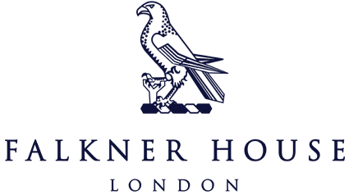

Y3 Match report v Norland Place

4th October 2024

What was meant to be a day at the Norland Place tournament took a surprising twist when the event was cancelled. Rather than miss out on the opportunity to play, Falkner House extended a friendly invitation to Norland Place for a head-to-head fixture at Holland Park. It turned out to be a thrilling contest filled with drama, determination and an outstanding comeback.

The game got off to a tough start for Falkner House, with Norland Place quickly establishing a 2-0 lead in the first half. Their sharp passing and quick attacks left Falkner with some early work to do.

However, the boys did not let their heads drop. After a halftime team talk that emphasised belief and teamwork, the boys came out with renewed energy and purpose. Within minutes, Falkner House pulled one back, courtesy of a skillfully placed shot from Maximillian which gave the team a much-needed boost. More goals followed in quick succession; the 4-2 turnaround was complete.

The final whistle blew, and Falkner House celebrated a hard-fought and well deserved victory. The boys showed immense character, coming back from 2-0 down demonstrating grit, teamwork and skill.

Well done boys!