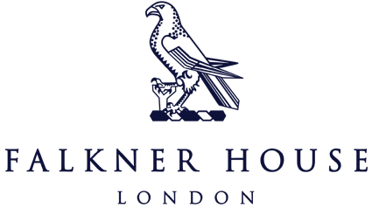

Y3 Match report v Eaton House

23rd September 2024

Albion and Rovers

In a thrilling display of teamwork and enthusiasm, the Year 3 Albion team took to the field against Eaton House. The first half was an exciting spectacle, with Albion showing their strength and skill early on. Their passing was crisp, and their communication on the pitch made all the difference. The boys were not only impressive in their footballing ability, but also in their sportsmanship, with handshakes and smiles exchanged after every challenge. Despite the competitive nature of the match, it was clear that the emphasis was on enjoyment and respect for the game and each other. By the end of the first half, Albion secured a confident lead, ready for Rovers to come on for the second half.

It was time for Falkner House Rovers to step on the pitch and face the same Eaton House team. Rovers brought fresh energy to the game, with every player eager to make their mark. The second half was closely contested, but Falkner House Rovers managed to secure another victory by the final whistle.

Well done to Albion and Rovers for their hard work, and congratulations to all the players for a day of football filled with fun and camaraderie.

City and United

City played the first half and started very strongly with all the boys pressing the ball and putting Eaton House under pressure. The pressure was rewarded with an early goal. The boys continued to create lots of opportunities with their passing and crosses. The half ended with a comfortable victory for City.

United came on for the second half to continue the momentum. Like City, United started brightly with very good passing and supporting each other by finding space for those passes and defending really well. It was a very good, evenly matched half which ended in a draw.

Well done to City and Albion for their focus and hard work.