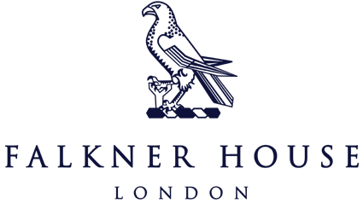

Match report Y6

Durston House Tournament

**A Football Triumph: The boys were runners-up at the Durston House Tournament**

In a stellar display of skill and teamwork, Falkner House secured a commendable second place finish at the highly competitive Durston House football tournament. The team’s impressive journey saw us clinch victory in six matches, draw one and experience a lone defeat against the eventual winners.

Throughout the tournament, Falkner House showcased superb defensive prowess by conceding a mere three goals, a testament to our solid backline of Marlowe, Max and Alexander J. Henry P deserves a special mention for his unbelievable shot stopping in goal. Future England number one? On the offensive front, our attacking threat of Raphael, Lucas, Ameen and Alejandro were a constant menace to the opposition, finding the back of the net an impressive twelve times, highlighting our proficiency in turning opportunities into goals.

The camaraderie and determination exhibited by the Falkner boys were key factors in our success, earning them the respect of opponents and spectators alike. Despite narrowly missing the top spot, Falkner’s performance undoubtedly left a lasting impression, and their journey in the Durston House tournament will be remembered as a remarkable chapter in their football legacy. Well done boys, we are all so proud of you!