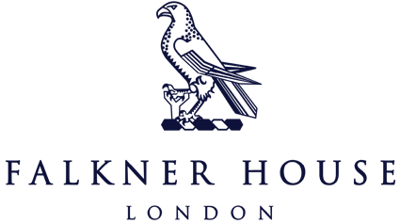

Match Report Y3 v Norland Place

9th October 2023

The Albion Team looked to continue the momentum after their opening win at Eaton House, facing Norland Place at home. This game proved to be an evenly matched contest. In the first half, Norland Place took the lead twice, but the Albion Team responded with two goals of their own: a long-range goal from Zavi and a tap in from Jad. The conclusion of the half saw Norland Place score once more. Theo in goal making a couple of really good saves and great defending from Alessandro and Rory, to keep Albion in the game.

The second half saw Albion have a strong start and equalise quickly with Jad scoring his second goal of the game. However, Norland Place immediately took the lead once again, but they kept the momentum and doubled their lead soon after. Albion put on the pressure to come back into the game and did pull one back from Zavi for his second goal. But Norland Place restored their two-goal advantage at the end with the final score 6-4 to Norland Place.

Overall, a very good even game that could have been any result. The boys enjoyed themselves and kept the heads up after the match. Well done boys.

In an incredibly close football showdown, Falkner House United emerged victorious with a 4-3 win against Norland Place. The match was a thrilling back and forth contest that had all spectators on the edge of their seats.

Falkner House displayed exceptional teamwork, skill and understanding of the positioning side of the game, securing their victory in the closing moments. Goals from both sides were met with roaring cheers. The boys are improving their football knowledge every time they play which is wonderful to see. Well done United. Player of the Match – Otto!