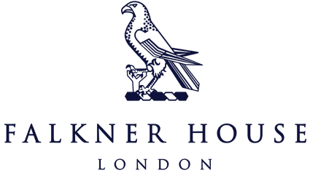

Friday 6th October

Year 3 Tournament Report

Selected boys from Year 3 took part in the Norland Place football tournament on Friday securing an impressive 3rd place finish. The boys played a total of four games, winning two, drawing one and losing one. Each match was very closely contested and on another day the boys could have won all four!

The boys demonstrated determination and sportsmanship throughout the competition. Their victories highlighted their commitment to the game, while the draw reflected their ability to hold their ground when faced with tough opponents. Although they experienced a setback in one match to the eventual winners of the competition, the team's overall performance left everyone proud of their effort and dedication.

Congratulations to all five boys, we are incredibly proud of you all. Now let's look forward to the Cothill House tournament this week!

Special mention to Alexander who won the Golden Boot award for being top scorer on the day with an incredible SEVEN goals in four games. Well done, Alexander!

Results:

Falkner House 2 - 2 Notting Hill Prep

Falkner House 2 - 3 SIAL

Falkner Houe 3 - 2 Norland Place

Falkner House 2 - 0 Garden House