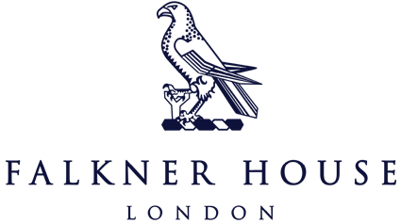

Falkner House Cross Country

6th October 2023

On Friday 6th October Falkner House boys took part in the Falkner House inter school cross country event hosted by Falkner House girls in Battersea Park. It was a great day for running, the sun was up, the grass was green, and the boys were ready to run.

After some unrelenting dedication to the cause, our boys were exhausted but satisfied knowing they had given their all.

The Year 3 boys performed admirably amongst a strong field.

The Year 4 boys gave it their all and finished in strong positions in another packed field of talent. Jack showed serious heart (and lung capacity) to power home in 5th position.

In Year 5, our boys were able to hold their own and bring home gold in the form of Hamish’s outstanding effort. A late push that put Hamish under serious pressure nearly put Bear in the number one spot, but he finished in a very tight second to make it a Falkner House 1st and 2nd. With point contributions from Toby and Felix, the Year 5 boys got their hands on the trophy.

Despite the end of the race providing drama worthy of Coronation Street, the Year 6 boys showed their prowess. Alex bringing home gold in a comfortable, steady run, barely breaking a sweat in the October sun. Second was Lucas and in a remarkable 1st, 2nd, 3rd for Falkner House, young Ameen was closely at hand. Marlowe provided crucial points for the team, and it resulted in Falkner House bringing home the silverware.