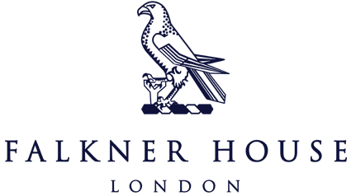

Match report Y6 v St Philip’s

Friday 15th September

A challenging start to the season for United facing tough opposition. The boys started well, taking a 1-0 lead but St Philip’s equalized almost straight away. Despite our best efforts, United found it difficult to maintain possession and defend against St Philips’ relentless attacks resulting in our first loss in a long while. A bad day at the office for the boys, but plenty to learn from, some positives to focus on and no doubt we will come back stronger! Man of the Match goes to Max. Max showed great leadership skills, determination and battling to win every ball. On to the next one!

Rovers played their first game of the season against St Philip’s at home. The start of the game saw the Falkner House boys, led by Rex, Jai Veer & Alec, putting St Philip’s under pressure, trying to win the ball high up the pitch. Their pressure paid off by scoring 4 goals in the first half. The second half started more evenly. St Philip’s tried to get back into the game, but the defensive efforts from Isaac, Alex and Dominic (goalkeeper) made sure they didn’t get many chances and kept a clean sheet. Eventually, the team scored another 3 goals with Alec scoring a hat-trick.Overall, a great team performance. Lots of communication between the boys throughout the game and helping each other out.

City played football against St Philip’s. The Falkner House boys started aggressively; rarely letting St Philip’s out of their own half. After just 10 minutes Falkner House were up 3 goals, with Henry S scoring 2 of them. Rather than being deflated at being 3 goals down St Philip’s started to play some positive football and pulled back 2 goals before the end of the first half. St Philip’s started the second half the same way they had ended the first and scored a third goal to make it 3 goals each. For the next 10 minutes the game was in the balance as both teams had chances to take the lead. Finally, in the last 5 minutes Falkner House were able to score 3 quick goals and end any chance of St Philip’s winning. It really was a team effort, and particular mentions to Oliver, Henry S, Henry P and Pietro.